Aws ec2 -task

- Launch one EC2 using Amazon Linux 2 image and add a script in user data to install Apache.
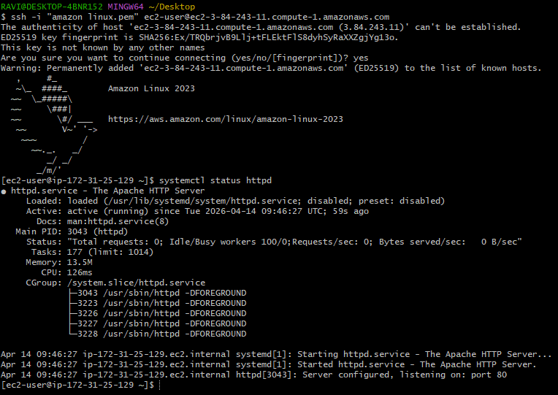

- Launch one EC2 using Ubuntu image and add a script in user data to install Nginx.
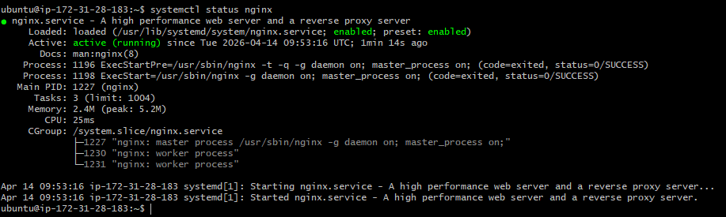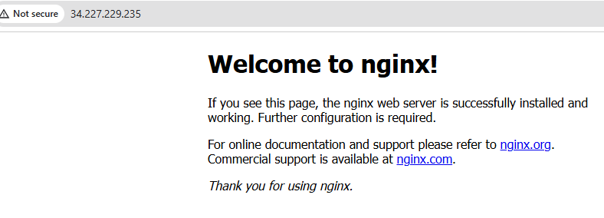

- Launch one Windows server and install Tomcat on Windows.
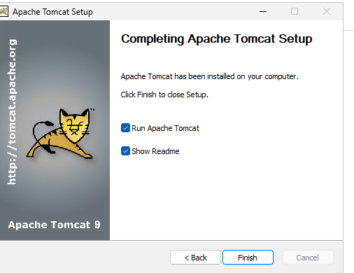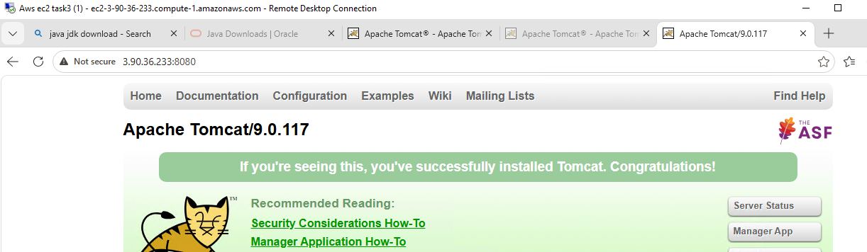
- Take a snapshot of the instance created in Task 1. 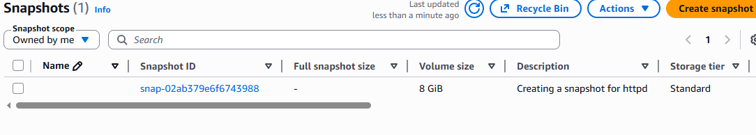

- Assign passwordless authentication for the EC2 created in Task 2.
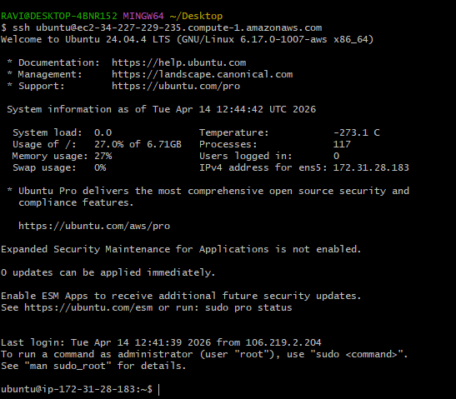
- Launch any EC2 using the spot purchasing option. 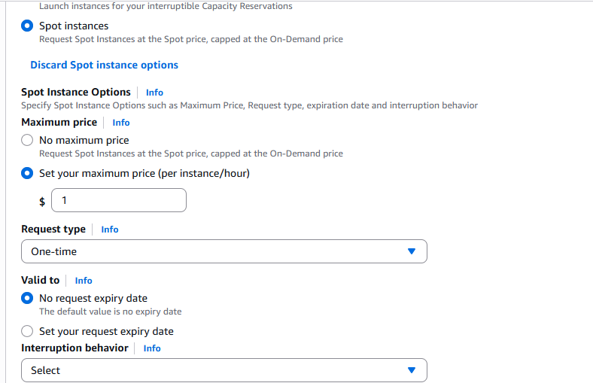
- Enable termination policy on the EC2 created in Task 2.
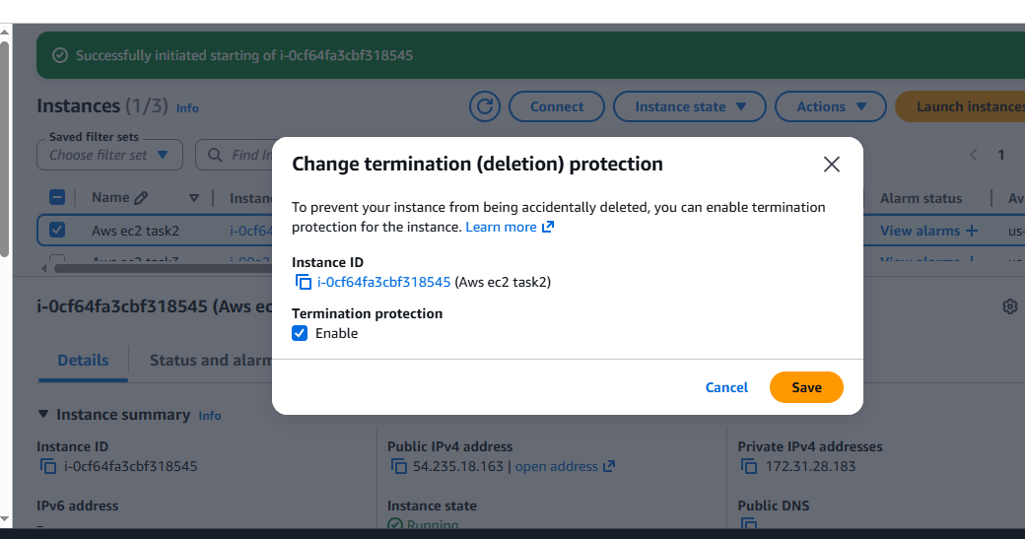

- Launch one EC2 using AWS CLI.
